MOVE DEFENSE

CONDUCT A DISENGAGEMENT BY A PLATOON
WHILE UNDER ENEMY PRESSURE
071-326-5832

CONDITIONS

As an acting rifle platoon leader in a field training exercise (FTX), given a 1:50,000 map of the area of operations, and a requirement to plan for a withdrawal under enemy pressure as part of a larger force.

STANDARDS

Prepare a plan that includes, as a minimum, the sequence of withdrawal and methods of disengagement.

TRAINING AND EVALUATION
Training Information Outline

1. A platoon’s withdrawal under enemy pressure is conducted as part of a company’s withdrawal. The withdrawal is conducted when the company is forced from its defensive positions, to either continue the defense or disengage and move elsewhere for another mission. Each platoon tries to disengage from the enemy by fire and maneuver to the rear. Once a platoon has disengaged and moved to the rear of its original position, the company commander will direct what it is to do next. This may include covering the rearward movement of other platoons, occupying a new defensive position, or moving to perform another mission.

2. The company commander controls the sequence of withdrawal of the platoons. His decision on which platoon to withdraw first is usually based on where the enemy attacks and how heavily each platoon is engaged. Once the decision is made to withdraw, the company commander will normally order the least heavily engaged platoon to withdraw first. That platoon then disengages and moves to a position where it can overwatch the disengagement of the more heavily engaged platoons. The platoons then change roles and leapfrog to the rear using fire and maneuver. This leapfrogging continues until contact is broken or the company reaches a new defensive position (Figure 1).

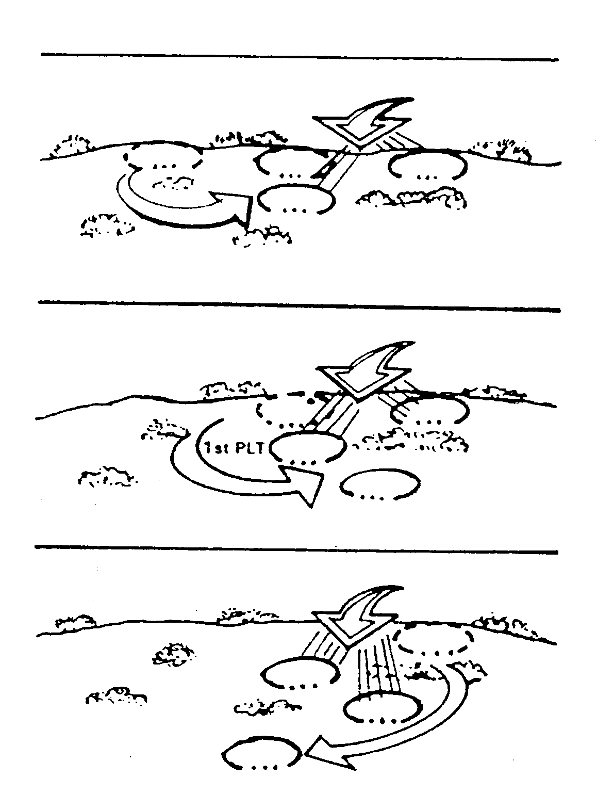
1st PLT
2d PLT
3d PLT
2d PLT
3d PLT
2d PLT
3d PLT
1st PLT

Figure 1. Withdrawal under pressure.

3. Platoons have three basic methods of disengaging from the enemy: by thinning the lines, by fire teams, and by squads. Fire and maneuver and bounding overwatch are keys to each method. The degree of fire and maneuver and bounding overwatch depends on how closely the enemy follows and the pressure he applies.
a. Disengagement by thinning the lines. The first stage of the fire and maneuver rearward is in the squads. Squad and team leaders have men move rearward singly to where each takes a firing position to cover the move of the others as they, in turn, move back (Figure 2).

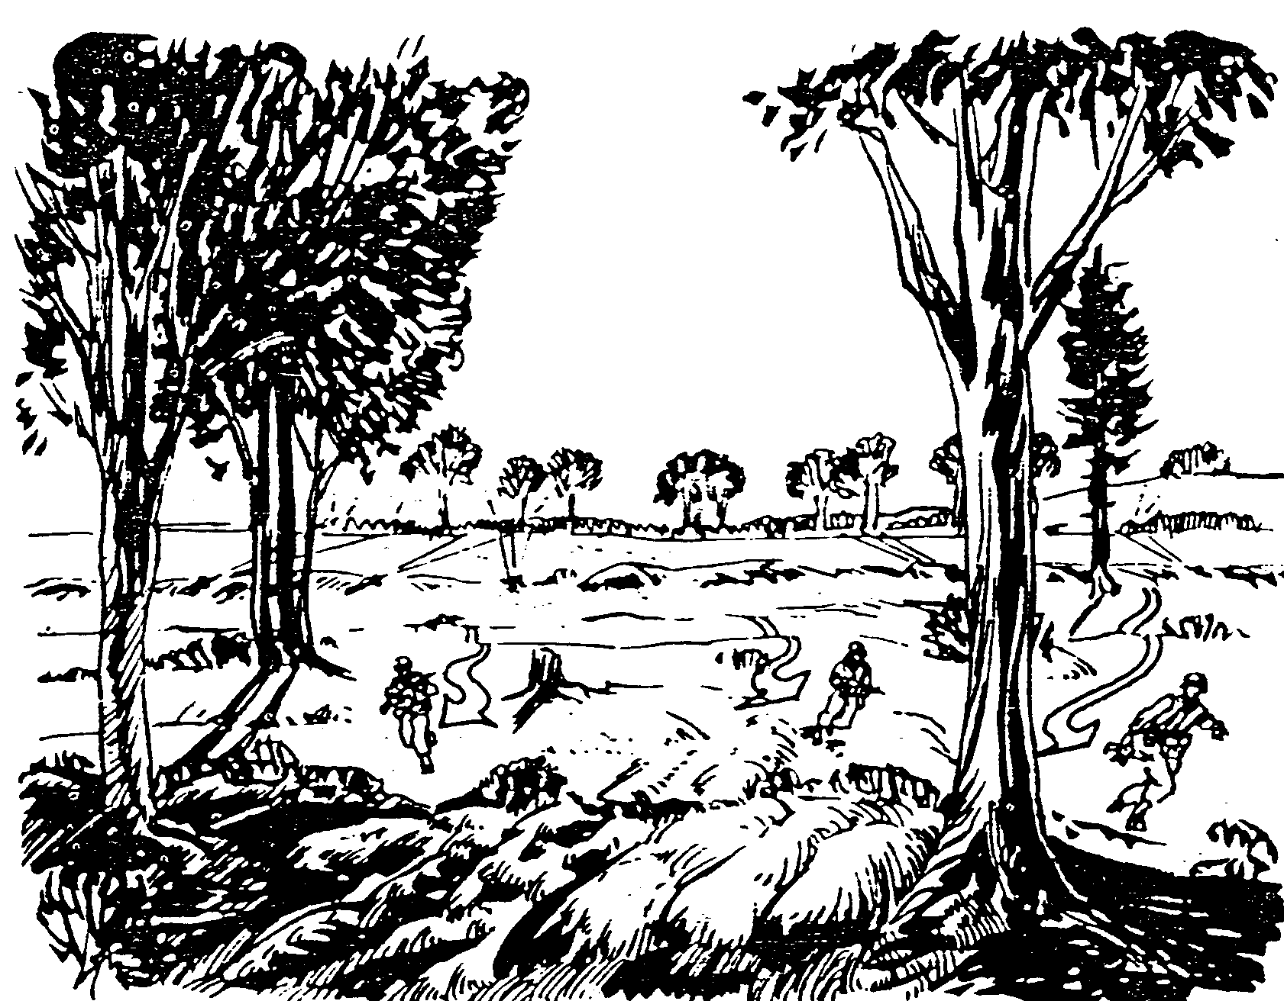

Figure 2. Thinning the lines.

b. Disengagement by fire teams. If enemy fire is such that thinning the lines is unnecessary, or if the squads have moved back far enough to make it unnecessary, the squads move back by fire teams. One team fires and the other moves. They alternate roles with each move (Figure 3).

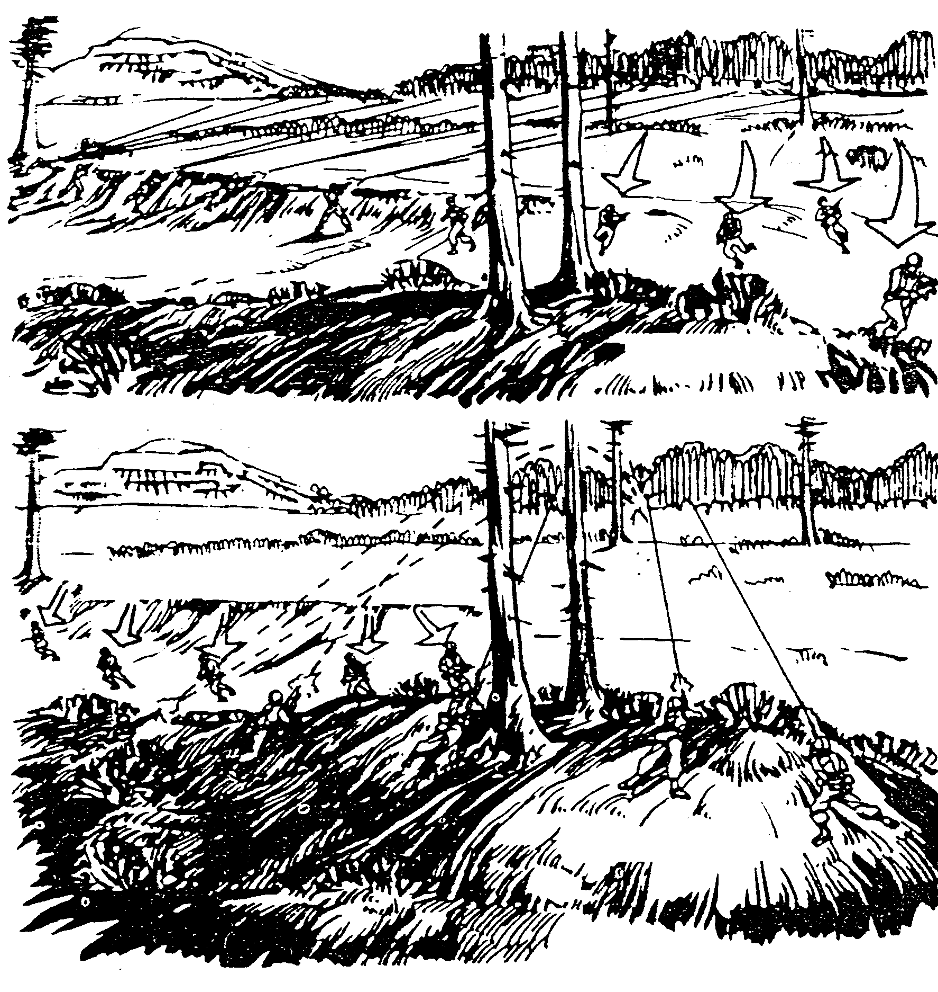
FIRE TEAM A MOVES
FIRE TEAM B MOVES
FIRE TEAM A MOVES
FIRE TEAM B
MOVES

Figure 3. Disengagement by fire teams.

c. Disengagement by squad. If enemy fire is such that fire and maneuver by fire teams is unnecessary, or if squads have moved back to a point where it is no longer necessary, the platoon moves back by squads. The platoon leader has each squad, in turn, move back covered by the fire of the others (Figure 4).

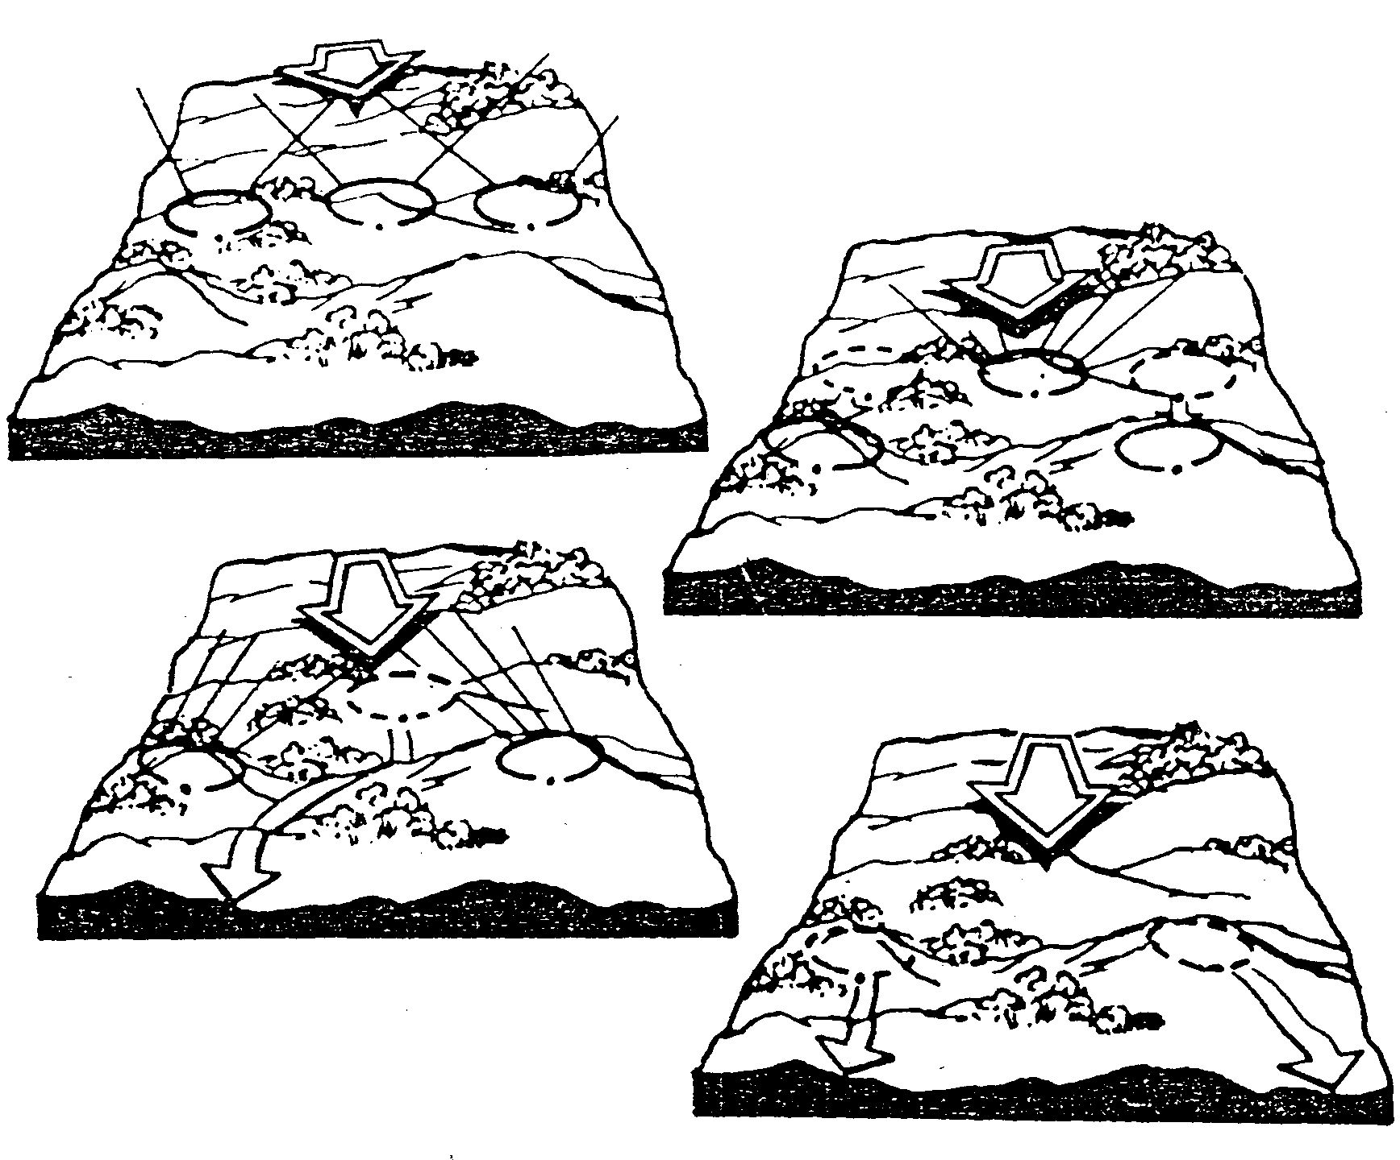
A
B
C
D

Figure 4. Disengagement by squad.

4. The platoon may use all three methods of disengaging as it moves rearward. As enemy fire lessens, the platoon changes to the next faster method of disengagement (first by thinning the lines, then by fire team, and then by squads). It uses only those methods necessary for its safety while moving.

5. At some point in the action, the platoon can stop fire and maneuver. It then continues its withdrawal by bounding overwatch to the rear (Figure 5). This occurs when the platoon is no longer under enemy direct fire or when another platoon is covering its move. Once disengagement is complete, the platoon moves as directed by the company commander.

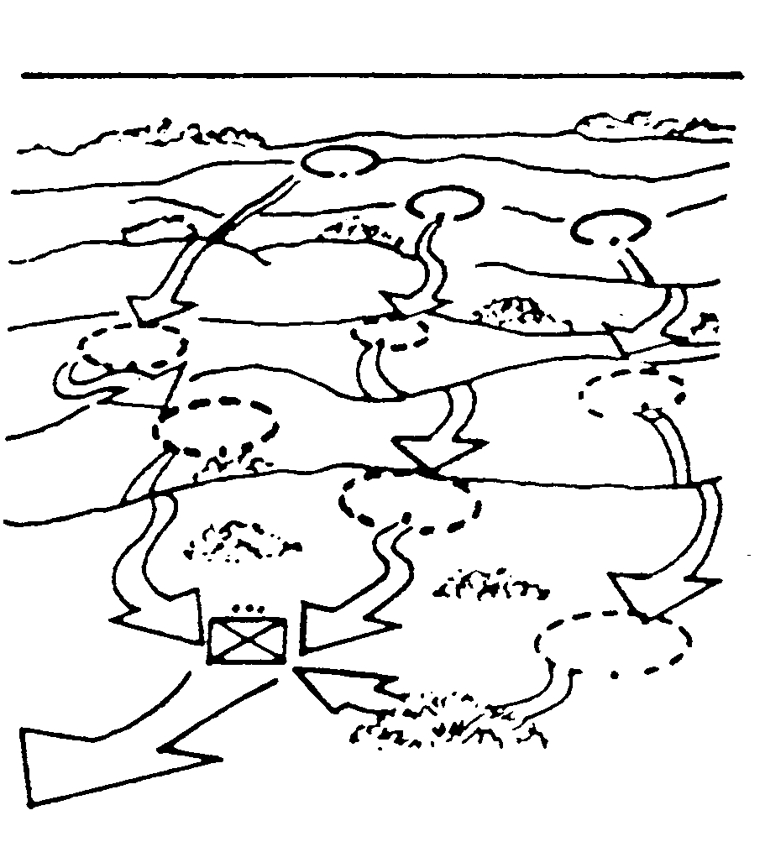
1
2
3
4
5
6
7
8
9

Figure 5. Bounding overwatch to the rear.

6. Because the actions taken during a withdrawal under enemy pressure depend a lot on the enemy’s action (for example, which squad is the most heavily engaged, and the uncertainty of when the enemy will attack), you may have little time, if any, to plan for the withdrawal. You should therefore prepare a contingency plan for a withdrawal each time a platoon moves into a defensive position. Control measures, such as the signal to begin the withdrawal, the location of the next position, and routes to that position, should be planned, and each member of the platoon should know them. Also, if time and the situation permit, each member should actually walk the route of expected withdrawal. If time permits, and before a plan for the platoon’s withdrawal is begun, you should check with the company commander and find out what the company’s plan is; this will ensure that your plan will support the company’s.

EVALUATION PREPARATION

Setup: At the test site, with information given in the task conditions statement.

Brief Soldier: Tell the rifle platoon leader to fix and assault the enemy. The leader must take appropriate action to maneuver the element in order to prevent serious injury or casualties to personnel. The leader will be given the enemy situation.

EVALUATION GUIDE

Performance Measures Results

1. Platoon withdraws under pressure. P F

2. Company commander controls sequence. P F

3. Platoon uses a method of disengagement. P F

FEEDBACK

Score the soldier GO if all steps are passed. Score the soldier NO-GO if any steps are failed. If the soldier fails any steps, show what was done wrong and how to do it correctly.

REFERENCES

Required Related
None FM 7-7
FM 7-7J
FM 7-8

